(By Subrata Sir & group of ICSE and CBSE school teachers)

GUIDELINES

# Class X Mathematics

**Mock Paper – 2 (2023)**

# Time: 2 ½ hours Total Marks: 80

**General Instructions:**

1. *Answers to this Paper must be written on the paper provided separately.*
2. *You will not be allowed to write during the first 15 minutes. This time is to be spent in reading the question paper.*
3. *Omission of essential working will result in loss of marks.*
4. *Attempt* ***all*** *questions from* ***Section A*** *and* ***any four*** *questions from* ***Section B****.*
5. *The intended marks for questions or parts of questions are given in brackets [ ]*

**Section - A**

(Attempt **all** Questions from this Section)

**[ 15 ]**

**1**. Choose the correct answers to the questions from the given options:

*(i)* What is the common difference of an AP in which a18-a14 =32?

(a) 8 (b)-8 (c) – 4 (d) 4

*(ii)* If in $∆$ ABC and $∆$ EDF, $\frac{AB}{DE}= \frac{BC}{FD}$, then they will be similar, when

(a) $∠$ B = $∠$ E (b) $∠$ A = $∠$ D (c) $∠$ B = $∠$ D (d) $∠$ A = $∠$ F

*(iii)* PQ is a tangent to a circle with centre O at the point P. If $∆$ OPQ is an

isosceles triangle, then $∠$ OPQ is equal to

(a) 30° (b) 45° (c) 60° (d) 90°

*(iv)* Two unbiased coins are tossed simultaneously then the probability of

getting no head is $\frac{A}{B}$, then (A+B)**2** is equal to

(a) 1 (b) 4 (c) 5 (d) 25

*(v)* A solid ball is exactly fitted inside the cubical box of side $a$. The volume of

the ball is

(a) $\frac{1}{6}πa^{3}$ (b) $\frac{4}{3}πa^{3}$ (c) $\frac{1}{3}πa^{3}$ (d) None of these

*(vi)* If the points A (4,3) and B (x, 5) are on the circle with centre O (2,3),

then the value of x is

(a) 0 (b) 1 (c) 2 (d) 3

*(vii)* If the discriminant of the equation kx2-3x+4 =0 is 14, then the value

of k is

(a) $\sqrt{2}$ (b) 3 $\sqrt{2}$ (c) $\sqrt{2}$ (d) 4 $\sqrt{2}$

*(viii)* The mean and median of a distribution are 14 and 15 respectively. The

value of mode is

(a) 16 (b) 17 (c) 13 (d) 18

*(ix)* The coordinate of the vertices of a rectangle whose length and breadth are 6

and 4 units, respectively. It’s one vertex is at the origin. The longer side is

on the X-axis and one of the vertices lies in second quadrant is

(a) (0, 0) (6, 4) (6, 0) (0, 4) (b) (0, 0) (0, 4) (6, 0) (6, 4)

(c) (0, 0) (6, 4) (-6, 0) (6,4) (d) (0, 0) (0, 4) (-6, 4) (-6, 0)

*(x)* If the polynomial $g$ (x)=x + $a$ is a factor of $f$ (x) and (x) = x3 + (x²+1) - 2x

+ 3. Then, the value of $a$ is

(a) 2 (b) 1 (c) 0 (d)-1

*(xi)* If A and B are two matrix of order m $×$ n and n $×$ p respectively, then the order of

AB will be

(a)n $×$ n (b) m $×$ p (c) n $×$ p (d) p $×$ m

*(xii)* The value of 'x' for which -12x>30 and x $∈$*N* is

(a) x <- $\frac{5}{6}$ (b) x>- $\frac{5}{6}$ (c) x > $\frac{5}{6}$ (d) None of these

*(xiii)* The point (0, 3) is invarient under reflection in

(a) the origin (b) X-axis (c) Y-axis (d) Both X and Y-

axes

*(xiv)* If $\frac{7m+2n}{5m+3n}= \frac{5}{4}$,then $m:n$ is

(a) 3:7 (b) 1:7 (c) 7:3 (d) 3:1

*(xv)* Ravi opened a recurring deposit with a bank for a period of 3 yr. If the bank

pay interest at the rate 7% per annum and the monthly instalment is Rs.

1200, then the interest earned in 2 yr is

(a) 1900 (b) 2200 (c) 2400 (d) 2100

**[ 4 ]**

**2.** *(i)* If $\frac{a}{b}=\frac{c}{d}$,then prove that $\frac{3a-5b}{3a+5b}= \frac{3c-5d}{3c+5d}$

*(ii)* Pankaj Mishra goes to a shop and buy a woollen coat having cost? Rs. 1270

(list price). The rate of GST 18%. He tells the shopkeeper to reduce the

price to such an extent that he has to pay Rs. 1270 inclusive of GST. Find

**[ 4 ]**

the reduction needed in the price of the woollen coat.

*(iii)* Prove that $\frac{\sin{θ}\tan{θ}}{1-\cos{θ}}=1+ \sec{θ}$.

**3.** *(i)* A solid toy is in the form of a hemisphere surmounted by a right circular cone.

The height of the cone is 3 cm and the diameter of the base is 4cm. Determine

the volume of the solid toy. If a right circular cylinder circumscribes the toy,

then find the difference of the volumes of the cylinder and the toy. [take, π =

**[ 4 ]**

3.14]

**[ 4 ]**

*(ii)* The line passing through A(-2,3) and B(4, b) is perpendicular to the line

2x-4y=5, find the value of b.

*(iii)* Use graph paper to answer the following questions.

(a) Plot the points P(4, 6) and Q(1, 2).

(b) P' is the image of P, when reflected in X-axis. Write down the coordinates of

p'.

(c) Q' is the image of Q, when Q is reflected in the line PP'. Write down the

coordinates of Q’

**[ 5 ]**

(d) Find the area of $∆$ PQQ'.

**Section - B**

(Attempt **any Four** Questions from this Section)

**[ 3 ]**

**4**. *(i)* If (x)=2x3 + mx² - 11x + n is divisible by (x-2) and (x+3), then find the

values of m and n.

*(ii)* Mr. Nambi has a recurring deposit account in a bank of Rs. 600 per month

at 10% per annum simple interest. If he gets Rs. 15900 at the time of

**[ 3 ]**

maturity, then find the total time for which the account was held.

*(iii)* Use a graph paper for this question, the daily pocket expenses of 200 students

in a school are given below



**[ 4 ]**

Draw a histogram representing the above distribution and estimate the mode from the graph.

**[ 3 ]**

**5.** *(i)* A= $\left[\begin{matrix}1 & 2 \\ 3 & 4\end{matrix}\right]$ and B= $\left[\begin{matrix}5 & 6 \\ 7 & 8\end{matrix}\right]$,then find AB and BA. Show that AB $≠$ BA.

*(ii)* In the given figure, O is the centre of the circle. Determine $∠$ AQB and

**[ 3 ]**

$∠$ AMB, if PA and PB are tangents and $∠$ APB = 75°.

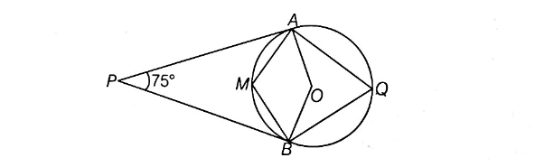

*(iii)* An employer finds that, if he increases the weekly wages of each worker

by Rs. 3 and employees one worker less, he reduces his weekly wages

from Rs. 816 to Rs. 781. Taking the original weekly wages of each worker

**[ 4 ]**

as Rs. x, form an equation in ‘x’ and solve it to find the weekly wages of

each worker.

**[ 3 ]**

**6.** *(i)* Prove that $\frac{\sin{θ-2\sin^{3}θ}}{2\cos^{3}θ-\cos{θ}}=$ $\tan{θ}$.

*(ii)* If the sum of first n terms of an AP is given by S**n** =6n+7n², then find the

**[ 3 ]**

nth term of the AP. Also, find 10th term of the AP.

*(iii)* Given a line segment AB joining the points A (-4, 6) and B (8,-3) Find

(a) the ratio in which AB is divided by the Y-axis.

(b) the coordinates of the point of intersection.

**[ 3 ]**

(c) the length of AB

**7.** *(i)* A bag contains 6 red balls, 8 blue balls and 10 yellow balls, all the balls of the

same size. If a ball is drawn from the bag without looking into it, then find the

probability that the ball

**[ 3 ]**

(a) yellow (b) red (c) not blue.

*(ii)* The volume of a conical tent is 1232 m**3** and the area of the base of the

floor is 154 m². Calculate the

(a) radius of the floor.

(b) height of the tent.

**[ 3 ]**

(c) length of the canvas required to cover this conical tent, if its width is 2 m.

*(iii)* In the given figure, C is the centre of the circle. $∠$ PCQ = 40° and $∠$ TSP =

**[ 4 ]**

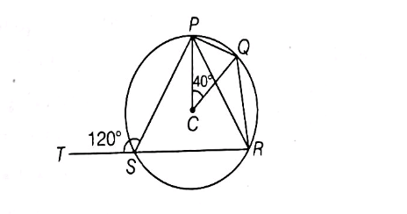 120°. Calculate $∠$ PQR and $∠$ QPR.

**8.** *(i)* Solve the following inequation and represent the solution set on the number line

**[ 3 ]**

-4 + $x$ $≤\frac{8x}{3}+1 ≤\frac{11}{3}+2x$, where $x$ $∈$*I*.

*(ii)* Find the mean of the following distribution using step deviation method.

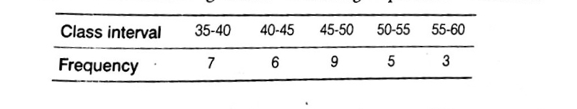

**[ 3 ]**

*(iii)* It is given that $∆$ ABC $\sim ∆$ EDF such that AB = 5cm, AC = 7cm, DF = 15cm

**[ 4 ]**

and DE = 12cm. Find the lengths of the remaining sides of the triangles.

**9.** *(i)* The eighth term of an AP is half of its second term and 11th term exceeds

**[ 4 ]**

one-third of fourth term by 1. Find the 15th term.

*(ii)* Draw an ogive for the following distribution

|  |  |  |  |  |  |  |  |  |
| --- | --- | --- | --- | --- | --- | --- | --- | --- |
| Marks | 0-10 | 10-20 | 20-30 | 30-40 | 40-50 | 50-60 | 60-70 | 70-80 |
| Frequency | 3 | 8 | 12 | 14 | 10 | 6 | 5 | 2 |

From the ogive, determine (a) the median. (b) the inter-quartile range.

**[ 6 ]**

**10.** *(i)* If the points A (6, 1), B (8,2), C (9.4) and D(p, 3) are the vertices of a

**[ 3 ]**

parallelogram, taken in order, then find the value of p.

*(ii)* Draw a circle of radius 7 cm. Draw a tangent to this circle making an

**[ 3 ]**

angle of 30° with a line passing through the centre of the circle.

*(iii)* The shadow of the vertical tower on a level ground increases by 50 m,

when the altitude of the Sun changes from 45° to 30°. Find the height of

**[ 4 ]**

tower correct to one decimal place.

X